Please Type Your Paper Title Here in   
14 Pts. Times New Roman, Title Case

First Authora*, Second Authorb, Third Authorc, Fourth Authord

aOrganization, City, Country

bOrganization, City, Country

cOrganization, City, Country

dOrganization, City, Country

**Abstract:** This is a template for the International Symposium on Future Instrumentation and Control for Nuclear Power Plants (ISOFIC 2024).The abstract for the full paper should be concise and do not exceed 2000 characters. The abstract should be written in 11 points, Times New Roman and placed before the first section with a horizontal line before and after. All text, tables, formulas, etc., presented in this paper are formatted according to the instructions below:

**Keywords:** Artificial Intelligence, Cyber Security, Human Reliability Analysis, list no more than 4 keyword phrases.

1. INTRODUCTION

Authors should submit their full paper in PDF file by online submission to [easychair.org/conferences/?conf=isofic2024](https://easychair.org/conferences/?conf=isofic2024) (click Add file) no later than 15 October 2024. It is important that the papers are formatted in accordance with the instructions herein to avoid delay on the electronic publishing. Papers should not exceed 10 pages (A4-size), including references and appendices.

The Conference Proceedings will be in electronic format. The use of color versions is encouraged in all pictures and graphics. The Conference Organizer will not be responsible for shifting of tables and graphics in the final publication.

It is important that the authors use their own technical editor and go through the paper to ensure the proper production quality.

2. FORMATTING AND UNITS

The text of the whole paper should be in 11 points, Times New Roman. Please do not use any special fonts or foreign text characters. All margins should be set to 2.0 cm. There is no indention of the beginning of a paragraph. The alignment of the paragraphs should be set at “justified” and separated by one blank line. All text should be set for single line spacing. Please do not use the page numbering and double column format in the preparation of the full paper.

3. ADDITIONAL REQUIREMENTS

3.1. Author Information

Write full names for the authors (first name last name). If there is more than one author, please put a, b, c, etc. in superscript after the name of each author, as indicated in the example above. If the authors have the same organization, city and country, please use one common letter and list the information once to identify them. Please put an asterisk (*) after the name of the contact author.

3.2. Headings, Tables and Figures

First level heading should be in bold, uppercase; second level headings in bold, title case; third level should be in regular title case, and underlined.

Text in tables should be at least Times New Roman 10 pt. Tables and figures have to be centered, numbered and must have titles. Numbers and titles of tables have to be above tables, and have to be centered. Numbers and titles of figures have to be below figures, and have to be centered. Examples of how to format a table and figure are presented below.

Table 1. Typeset of Papers

|  |  |  |  |  |
| --- | --- | --- | --- | --- |
|  | **Font** | **Size** | **Style** | **Paragraph** |
| Normal text | Times New Roman | 11 | Regular | Justified |
| Title of paper | Times New Roman | 14 | Bold, Title Case | Centered |
| Section titles | Times New Roman | 11 | Bold, Uppercase | Left |
| Subsection titles | Times New Roman | 11 | Bold, Title Case | Left |
| Authors’ names | Times New Roman | 12 | Bold, Title Case | Centered |
| Authors’ affiliations | Times New Roman | 11 | Regular | Centered |
| Abstract | Times New Roman | 11 | Regular | Justified |
| Keywords | Times New Roman | 11 | Title Case | Justified |
| Titles of tables and figures | Times New Roman | 11 | Regular, Title Case | Centered |
| Footnotes | Times New Roman | 10 | Regular | Justified |
| Formulas | Times New Roman | 10 | Italic |  |

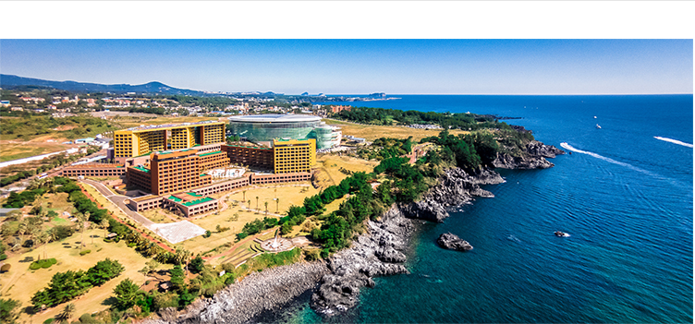

Figure 1. Booyoung Resort

Formulas have to be in italic, centered, and at the right side they can have numbers in parentheses, like in the following example:

*Tn = Tn-1 + 2n – 1* (1)

3.3. References

All references cited in the paper should be numbered according to their order of appearance using square brackets such as [1], [2,3] and [2-4]. The references should be listed at the end of the paper in the Reference Section. Please do not include references that are not cited in the paper.

Examples in the text:

1. This result was shown by Winkler [1].
2. This result has been shown in a recent study [1].

4. CONCLUSION

All paper should have a conclusion section to highlight the findings.

Acknowledgements

The acknowledgements for funding organizations etc. should be placed in a separate section at the end of the text. Thank you for your cooperation in complying with these instructions.

References

[1] Author A B and Author C D. Title of the article. The Journal, volume, page numbers (e.g. 110-120), year.

[2] Author E. Title of the book, The Publisher, city, year.

Examples:

[1] Winkler R L. Uncertainty in probabilistic risk assessment. Reliability Engineering and System Safety. 85, 127-132, 1996.

[2] Vose D. Risk Analysis: a Quantitative Guide, 3rd ed. Wiley, Chichester, 2008.

References for conference papers and reports should be in line with these examples, but detailed requirements are not given as we are flexible with respect to how the references are formulated, as long as structure and consistency are obtained.